Morphological Operations Using Closing
Experiment No: 32
Aim
To perform the morphological closing operation on an image using OpenCV in Python.
Tools Required
- Python 3.x
- OpenCV (cv2)
- NumPy
- VS Code / PyCharm / Jupyter Notebook
- Input image (image.jpg)
Theory
Closing is a morphological operation that is performed by applying dilation followed by erosion.
Closing is mainly used to:
- Fill small holes and gaps in objects.
- Connect nearby objects.
- Smooth the boundaries of foreground objects.
- Remove small dark regions
Procedure
- Install OpenCV and NumPy:
Bash
pip install opencv-python numpy
- Read the input image using OpenCV.
- Convert the image to grayscale.
- Create a structuring element (kernel).
- Apply morphological closing using cv2.morphologyEx().
- Display the original and closed images.
- Save the resulting image.
Code
import cv2
import numpy as np

# Read the image
image = cv2.imread("image.jpg")

# Check if image is loaded
if image is None:
print("Error: Image not found!")
exit()

# Convert image to grayscale
gray = cv2.cvtColor(image, cv2.COLOR_BGR2GRAY)

# Create a structuring element
kernel = np.ones((5, 5), np.uint8)

# Perform morphological closing
closed = cv2.morphologyEx(gray, cv2.MORPH_CLOSE, kernel)

# Display original image
cv2.imshow("Original Image", gray)

# Display closing operation
cv2.imshow("Closing Operation", closed)

# Save the closed image
cv2.imwrite("closed_image.jpg", closed)

cv2.waitKey(0)
cv2.destroyAllWindows()
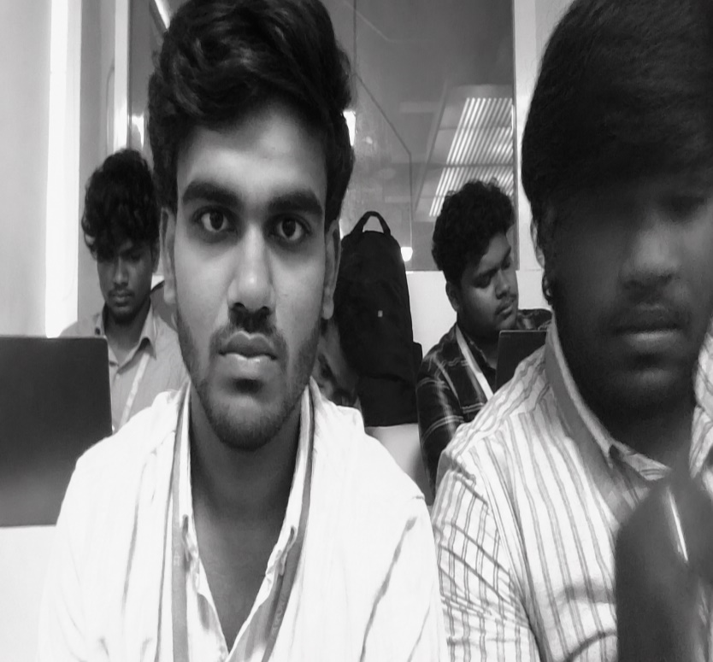
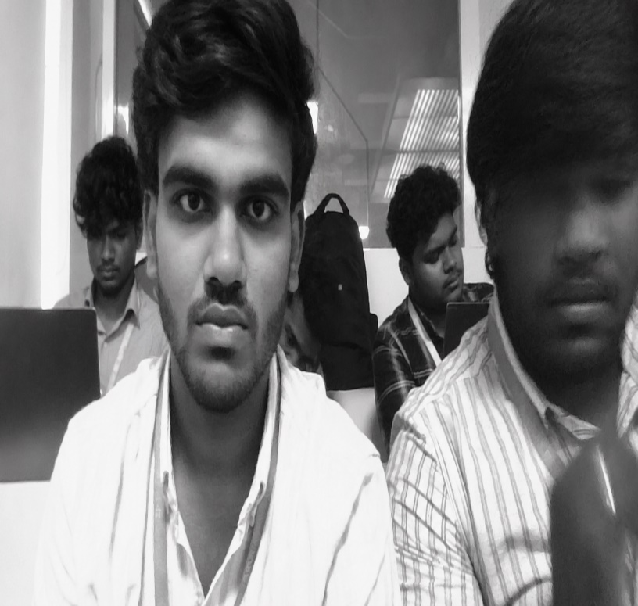
Output

Result

The morphological closing operation was successfully performed using OpenCV. The image was first dilated and then eroded using a 5 × 5 structuring element, successfully filling small holes and gaps and connecting nearby regions.

